**Google tag Manger**

GTM- Account Creation steps

1. Click: <https://marketingplatform.google.com/about/tag-manager/?hl=en_US>

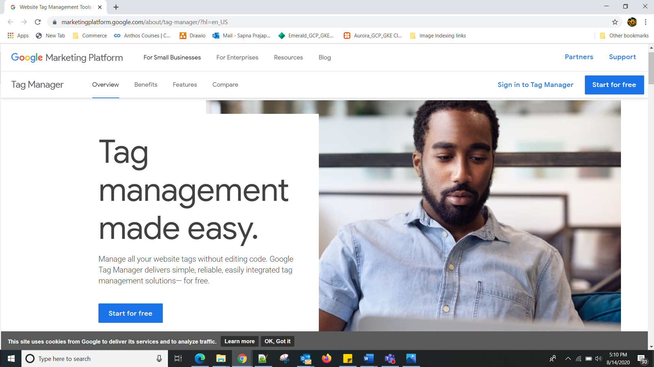

1. In Tag Manager, click **Accounts** and then **Create account**.

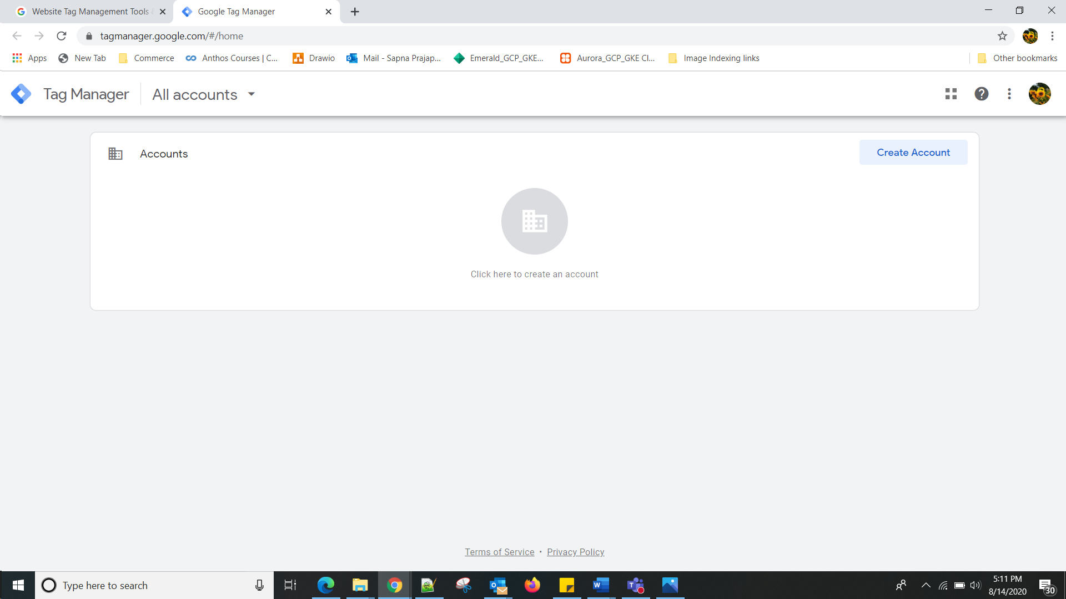

1. Enter an **account name** and optionally indicate whether you'd like to share data anonymously with Google and others.
2. Click **Continue**.
3. Enter a descriptive **container name** and select the type of content: **Web, AMP**, **Android**, or **iOS**. If setting up a mobile container, select whether you're using the **Firebase SDK** or one of the **legacy SDKs**.

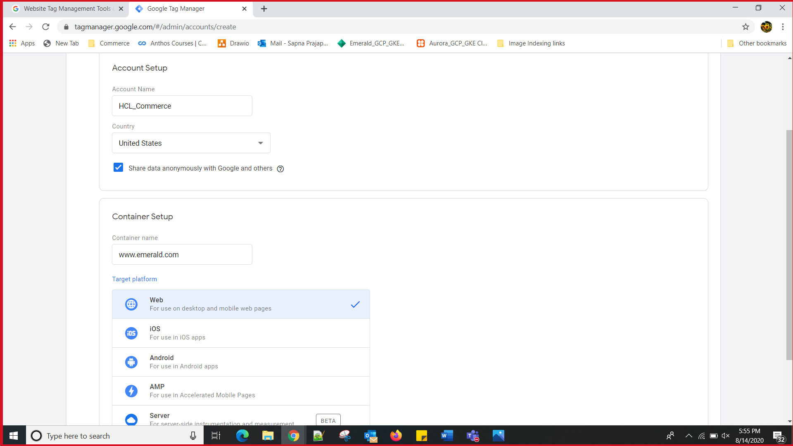

1. Click **Create**.
2. Review the Terms of Service and click **Yes** if you agree to those terms.

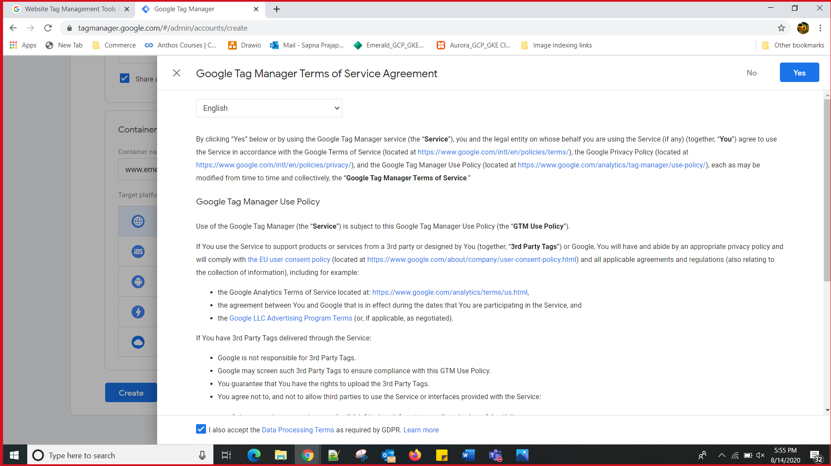



 find your container ID, formatted as "GTM-XXXXXX".

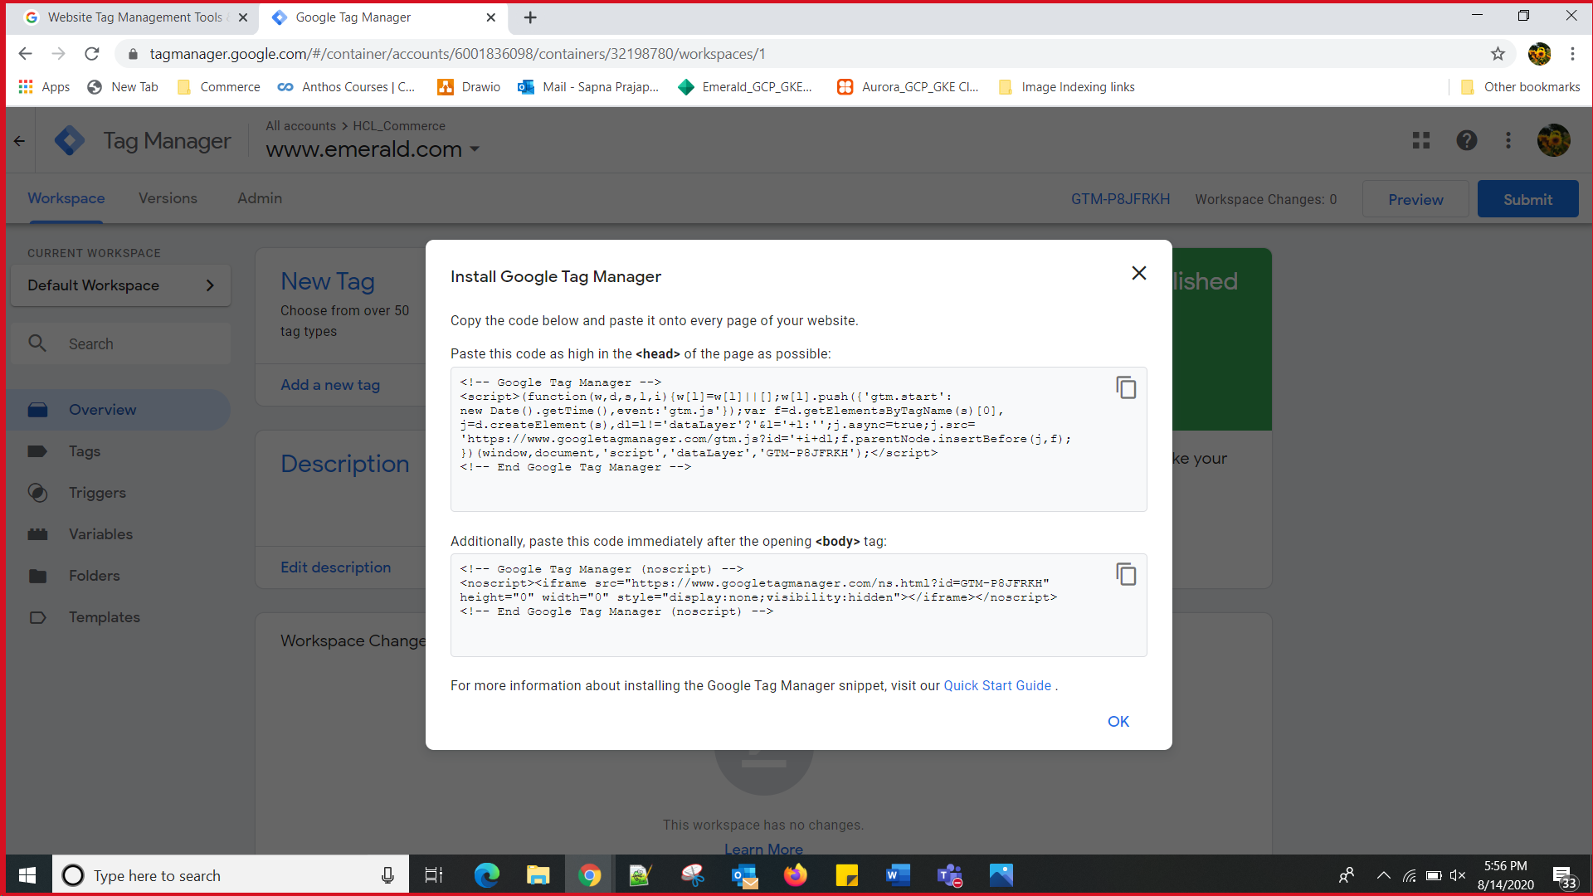

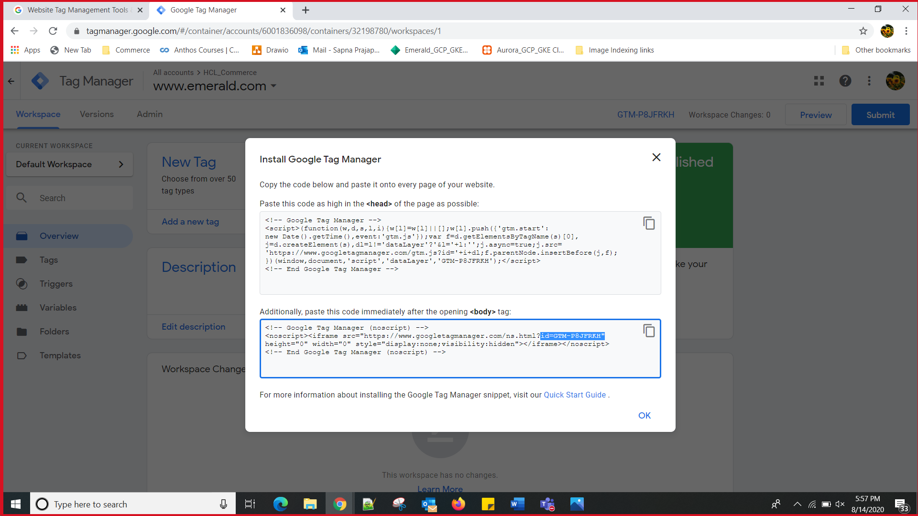

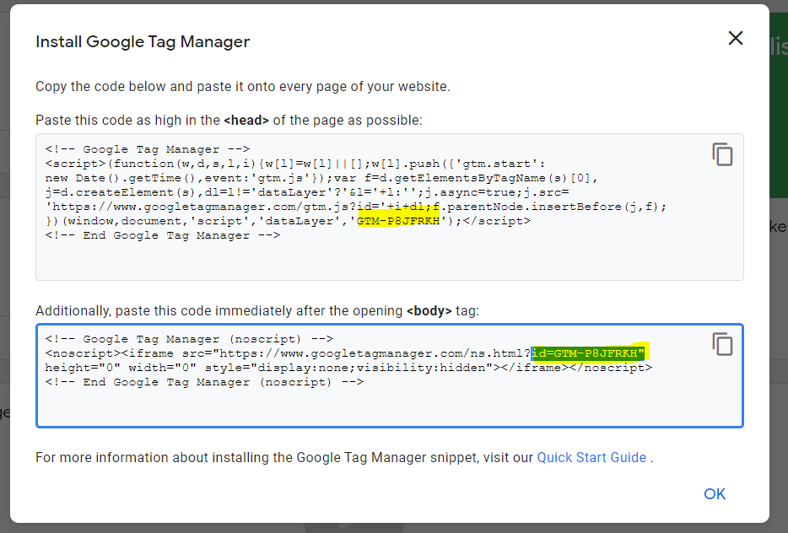

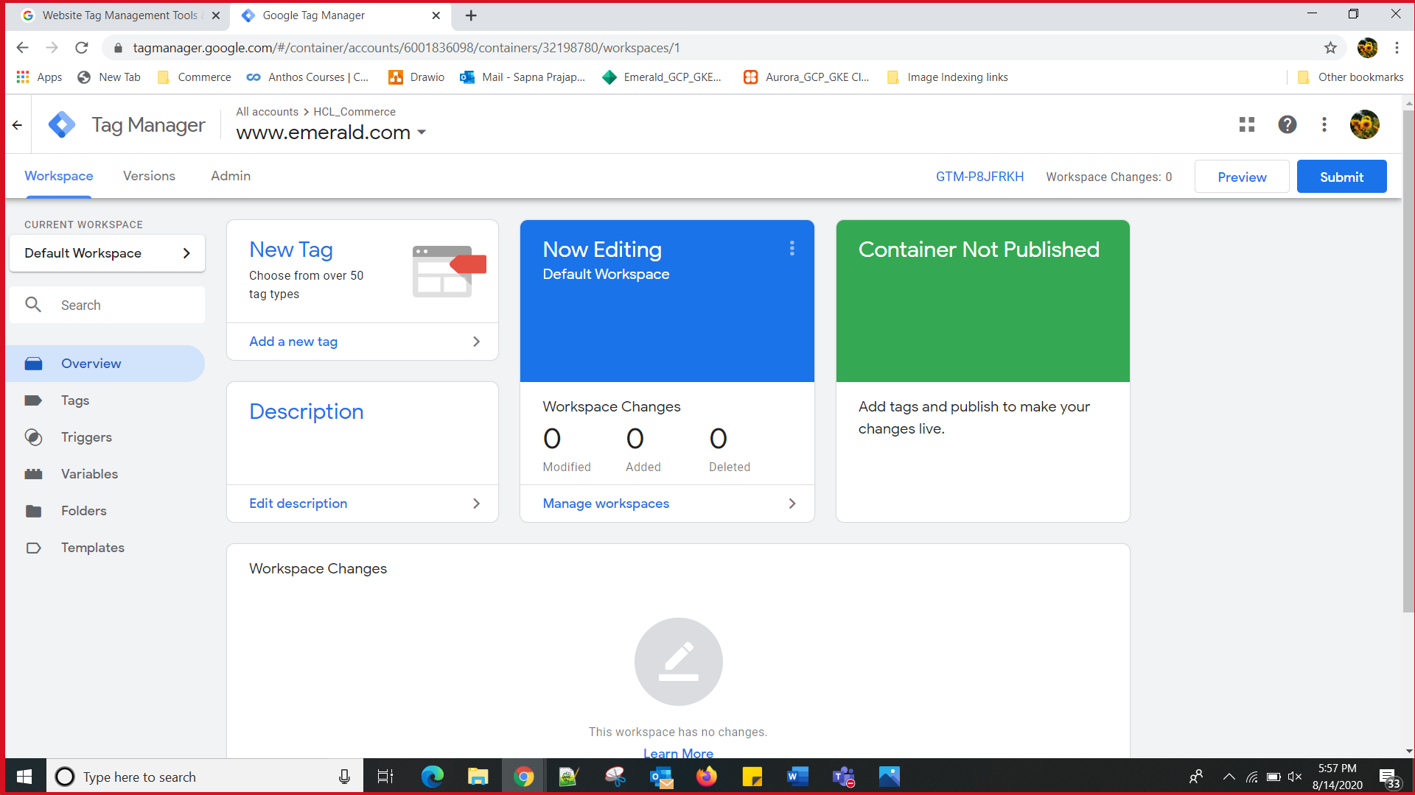

Reference : <https://support.google.com/tagmanager/answer/6103696?hl=en>